Experiment No.: 4
Title of the Experiment:
Implementation of Singly Linked List with Insertion, Deletion, and Display Operations

2. Mapped Objective and Mapped Outcome
Sr. No. | Mapped Course Objective (CO) | Mapped Course Outcome (CO No.)
1 | To perform basic operations such as insertion, deletion, and traversal on a singly linked list. | CO3: Apply appropriate data structures for solving computing problems.

3. Software and Tools Used
- Language Used: C++
- Compiler: GCC / Turbo C++ / Code::Blocks
- Operating System: Windows / Linux

4. Brief Theory, Algorithm / Flowchart
Theory:
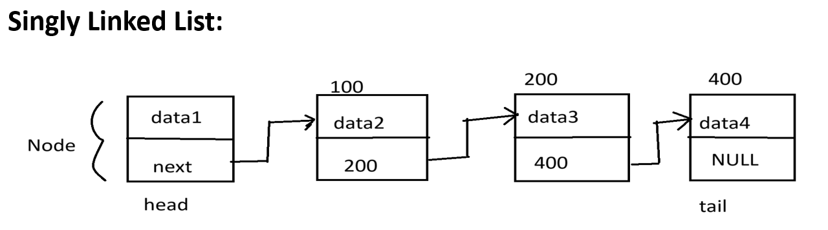
A Singly Linked List (SLL) is a linear data structure consisting of nodes, where each node contains two parts:
- Data field – stores the value or information.
- Pointer (next) – stores the address of the next node in the list.
Unlike arrays, linked lists use dynamic memory allocation, allowing flexible memory usage.
The last node’s pointer is set to NULL, indicating the end of the list.
Basic Operations:
- Insertion: Adding a new node at the beginning, middle, or end.
- Deletion: Removing a node from a specific position.
- Display (Traversal): Visiting each node to display its contents.

Algorithm:
Algorithm for Insertion at End
- Create a new node.
- Assign data to the new node.
- If the list is empty, make the new node as head.
- Else, traverse the list till the last node.
- Set last node’s next pointer to the new node.
- Set new node’s next to NULL.
Algorithm for Deletion of a Node
- If list is empty, display “List is empty.”
- If the node to be deleted is the head node, move head to next node.
- Otherwise, traverse the list to find the node to delete.
- Update previous node’s next pointer to skip the deleted node.
- Free the memory of deleted node.
Algorithm for Display
- Initialize a temporary pointer to head.
- While the temporary pointer is not NULL,
Print the data part.
Move to the next node.
Code:
#include <iostream>
using namespace std;
class Node {
public:
int data;
Node* next;
Node(int val){
data = val;
}
};
class List {
Node* head;
Node* tail;

public :
List(){
head = tail = NULL;
}
void push_front(int val) {
Node* newNode = new Node(val);
if(head == NULL){
head = tail = newNode;
return;
} else {
newNode->next = head;
head = newNode;
}
}
void push_back(int val) {
Node* newNode = new Node(val);
if(head == NULL){
head = tail = newNode;
return;
}
else {
tail->next = newNode;
tail = newNode;
}
}
void pop_front(){
if(head == NULL){
cout<<"LL is empty "<<endl;
return;
}
Node* temp = head;
head = head->next;
temp->next = NULL;
delete temp;
}
void pop_back(){
if(head == NULL){
cout<<"LL is empty "<<endl;
return;
}
Node* temp = head;
while(temp->next != tail){
temp = temp->next ;
}
temp->next = NULL;
delete tail;
tail = temp;
}
void print(){
Node* temp = head;
while (temp != NULL){
cout<<temp->data <<" ";
temp = temp->next;
}
cout<<"NULL" <<endl;
}
};
int main() {
List ll;
ll.push_front(10);
ll.push_front(50);
ll.push_front(05); //o/p: 5 50 10 NULL
ll.push_back(40); //o/p: 5 50 10 40 NULL
ll.push_back(55); //o/p: 5 50 10 40 55 NULL
ll.pop_front(); //o/p: 50 10 40 55 NULL
ll.pop_back(); // o/p: 50 10 40 NULL
ll.print();
return 0;
}

6. Conclusion
In this experiment, we successfully implemented a Singly Linked List in C++.
We performed basic operations such as insertion, deletion, and display using dynamic memory allocation.
This experiment helped us understand how linked lists manage memory efficiently compared to arrays and how pointers are used to connect nodes dynamically.

